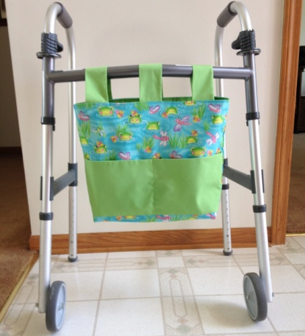

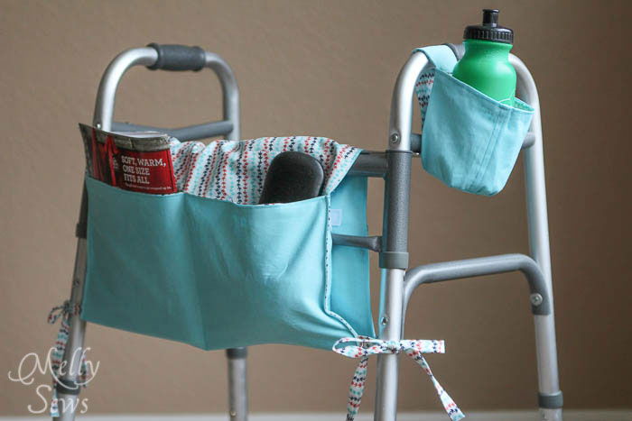
With front pockets for larger items…
And back pockets for items that need to be easily accessible (like glasses).
To make this caddy you’ll need
Two pieces of fabric measuring 18″ x 36″. One of these should be a heavier weight fabric – like heavy twill, denim, canvas, etc.
Ties or ribbon – I used ties made of 1/2″ wide bias tape sewn shut – you’ll need 1 1/2″ yards
1/2 yard of sew on velcro
To start, cut your two pieces of fabric to 18″ by 36″
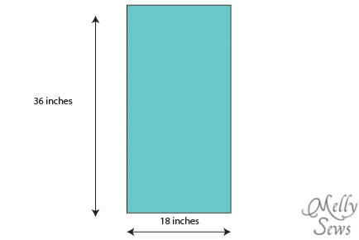
With your sturdier fabric wrong side up, fold the two ends up as deep as you want the pockets to be. I made the pockets on one side 8 inches deep and 5 inches deep on the other side. Iron these folds so that you leave a crease in the fabric. Then, with pockets still pressed up, fold the fabric in half right sides together and press that fold as well.
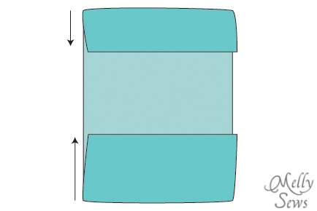
Cut your tie ribbon into 4 equal length pieces. Using your pressed creases as a guide, lay your fabric right side up and pin the ties right next to the pocket folds, and pin the velcro about 3-4 inches to each side of the center fold. Sew on velcro and ties.
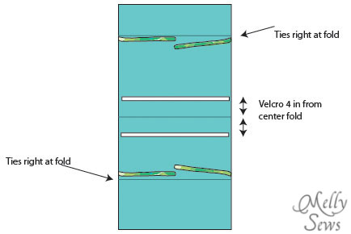
Place your other piece of fabric right sides together with your tied/velcroed piece and sew around the edges, stopping with your needle down at the corners to turn and leaving an opening for your hand to turn this right side out.
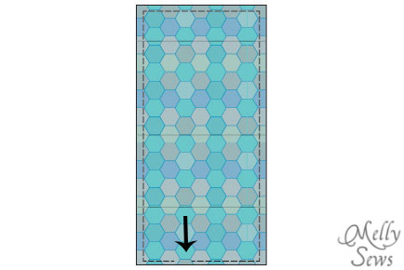
Turn the caddy right side out. Press the edges and topstitch all around the edges, closing the hole you used to turn the caddy right side out. Then fold the pockets back up and stitch down sides, backstitching to reinforce the top edges of the pockets. Sew dividing lines on the pockets, backstitching at these top edges as well.
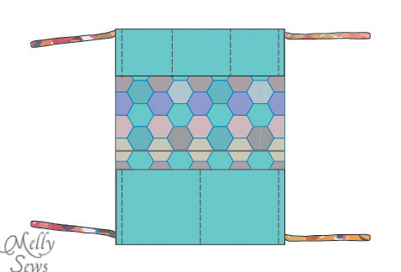
And then all that’s left is to fold this caddy onto the recipient’s walker, securing the velcro and the ties.
Happy sewing,
Related

